Twin Cities Technique

Ideas and configurations you may find helpful as you build your first portable 10 GHz dish system.

By Bruce Richardson, W9FZ

10 GHz activity is really growing in the Twin Cities. Over twenty operators are on the air. Several have built “loaner” rigs for others to borrow and have more people to talk to. For the past 6 weeks, we’ve even had a 10 GHz net on Friday nights where all bounce signals off of the tall buildings in downtown Minneapolis. Check-ins have been running between 8 and 13.

Each of us with portable systems had to conquer system integration issues developing a dish setup that is easy to use and reliable. This article is a photo-essay illuminating construction techniques that you may find useful as you build-up your portable dish system. This article will not address PTT line or IF level issues.

We determined the following goals:
- Single DC connection
- IF rig on dish and permanently connected
- Robust—survive banging abuse loading into and out of vehicle

You’ll see that we attempt to keep certain portions of our dish systems quite clean with no exposed equipment to make car travel less wearing on the setup. On other portions of the dish, where dish feeds and transverters are exposed, we willingly leave mounting hardware long enough to catch blows.
Figure 1 Hollow Center Tripods with Squat-Mod

Tripods:

Two basic types have been available to us surplus in the Twin Cities. Both types seem to have been used as lighting stands in the photography/marketing industry. One type has a hollow center tube and the other has a solid cylindrical bar at the center. You may not be able to find identical tripods but chances are some of the same concepts apply.

The hollow center tube type started life with wheels on each leg. Some guys don’t mind the wheels, but for weight and stability, most have removed the wheels and placed plastic chair-leg (or crutch-tip) caps on the legs. Rings (collars) riveted to each leg limit the leg spread. To lower the center of gravity and to make the tripod more difficult to tip over, many of us have performed the “squat mod”. The procedure involves drilling out the rivet and moving the stopper ring up each leg about ¾” and then fixing the ring with a stout sheet metal screw. When operating at windy locations, we prefer to lash the tripod to guardrail posts often found on the edge of parking lots. The alternative is to suspend a heavy gel-cell battery from the center of the tripod.

Plumbing:
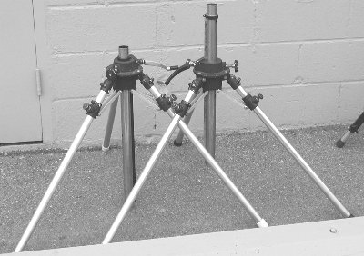
The starting point for attaching a dish to a tripod is a pipe. The pipe acts as a post in the hollow center tripods and as a collar in the solid center tripods.

For pipe material, your choices are basically iron, PVC, or copper. If you use PVC, I recommend Schedule 80 for stoutness. You will benefit from lighter weight with PVC but if your dish tips over, the PVC will likely break from the trauma. Steel/iron is strong but heavy. Copper (Type K or L) is lighter, generally stout enough, and has smooth joints via sweating. Further, by cutting copper pipe to your needed lengths, you are not constrained by commercially available lengths.

For hollow center tripods, one-inch pipe works well although you may need to wrap it with tape to reduce wiggle. Alternatively, you can use copper pipe as a shim spacer surrounding the iron pipe.
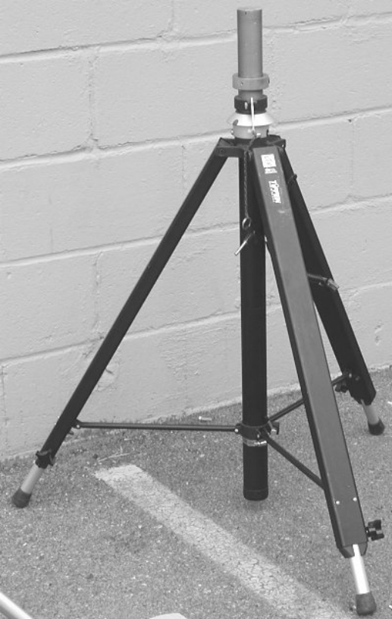
Figure 2 Solid Post Tripod
For solid center tripods, you’ll likely need pipe with a 1.25” ID to fit over the post.

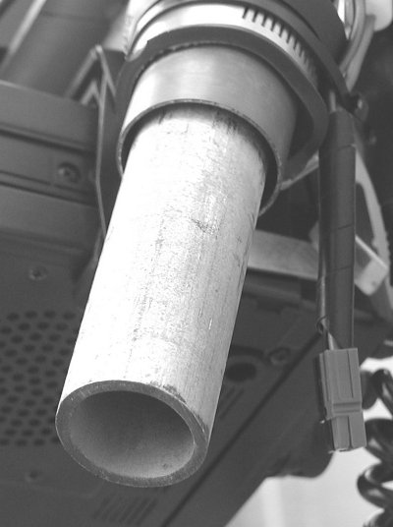
Figure 3 -- 1" pipe for hollow-center tripods
Next comes fashioning a pipe at the correct angle from vertical to which to mount the dish. 45-degree angle pieces work very well getting you in the range of adjustment offered by most offset fed dishes. Leave the stub long enough for when the dish is tipped forward (down) to the lowest elevation anticipated, it doesn’t contact the main post or the tripod. On the other hand, leave the stub short as possible to avoid suspending the dish far away from the center post generating a tipping moment. If your basic angled pipe is ¾” or 1” diameter yet your dish needs 1 1/4” or 1 ½” pipe to clamp well, you can use PVC pipe as a sleeve sliding over the pipe increasing its thickness. Pin the PVC thickening sleeve with a bolt through the PVC and the pipe piece.

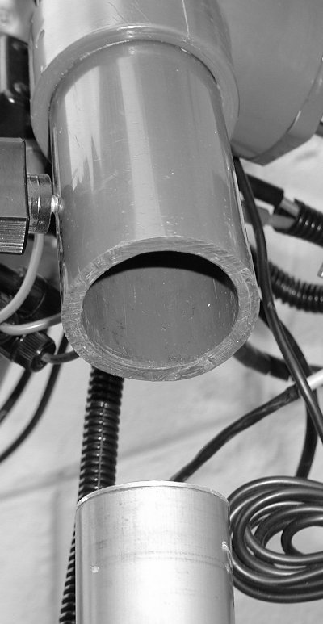
Figure 4 PVC pipe collar for solid center tripods. You can see a setscrew in upper left.

Expanding beyond this basic plumbing is what I call the “Twin Cities Technique”. Credit goes to Lenny KØSHF for taking that next step. Since one is already using stout plumbing for the tripod post and for the angled dish mounting, why not integrate additional pipe sections to which you can attach all the other necessary items like IF rig, keyer, speaker, and DC distribution? Plumbing pipe offers strength and the ability to configure the size you need through varying pipe lengths.

You can see that this additional plumbing can be as simple as a single horizontal stub.

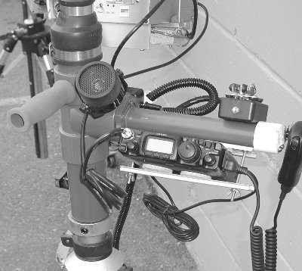
Figure KDØJI horizontal mounting stub
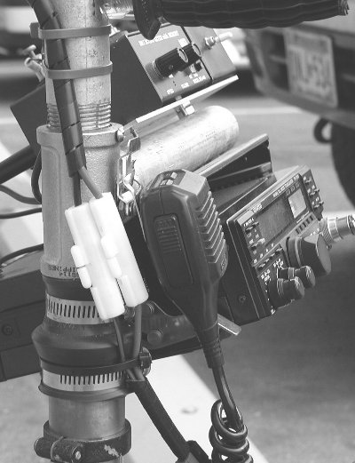
Figure 5 KØSHF horizontal mounting stub
At Aurora ’03, I saw a portable dish system constructed by KMØT. He had stout aluminum bar stock bent such that it gave him mounting locations on the inside of the area yet offered equipment protection from blows and a smooth surface to lay in his vehicle. Based on that idea, I built a square frame from plumbing pipe. With iron pipe, the frame gives me ample mounting locations between the frame and the dish. I achieved stoutness. The only drawback is that it is heavy. My goal was to have a clean back with no protuberances so that it could be placed easily and safely in the car. The stout frame and clean back allow me to throw the whole thing over my shoulder for hauls to prime operating locations.

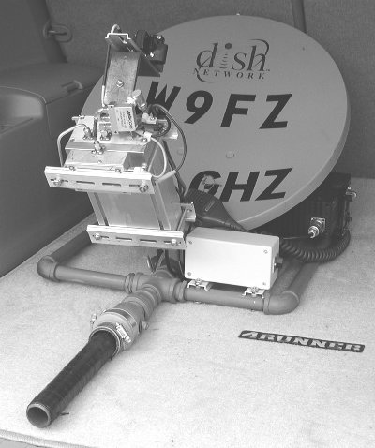
Figure 6 All items are on inside of frame leaving a clean back.
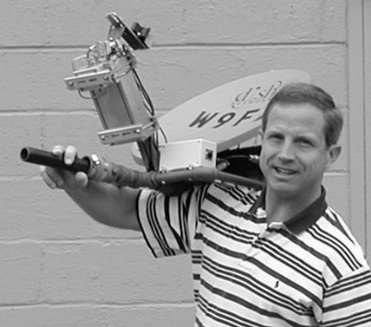
Figure 7 Clean frame back allows easy carrying and safe placement in vehicles.
Russ, WØLMS, has produced the ultimate compromise. He built a frame out of sweated copper pipe. His system is much lighter, still has a clean back, and yet has plenty of strength. If his dish fell over, his copper frame might suffer more trauma than my iron pipe frame but would still offer equipment protection. When I build up my second system, this sweated copper pipe style is how I will do it.

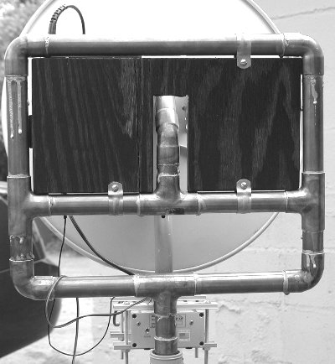
Figure 8 WØLMS's copper-pipe frame
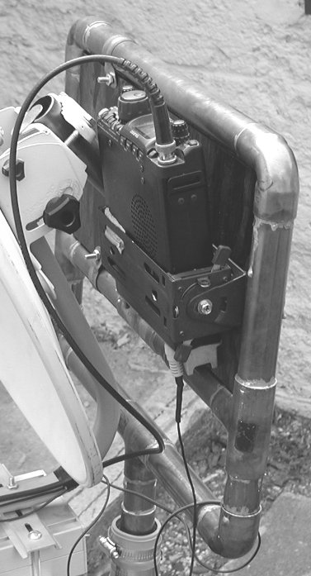
Figure 9 WØLMS's Ultimate System
DIN rail—a key ingredient:
Lenny KØSHF turned us on to DIN rail as a fabricating element. There are two types of DIN rail used in industry—big heavy stuff and lighter (and smaller) aluminum DIN rail. It is this lighter stuff that offers strength, flexibility, and usability. You can order it from Grainger (part# 6X295). It comes in 4’ lengths and costs less than a buck a foot. The center slots are where the flexibility comes in.

You can see that I used DIN rail to mount my IF rig on the “inside” of the plumbing frame. You also can see that many of us used DIN rail clamps to hold xverters firmly on the feed-arm. We made a clamp for the transverter between two pieces of DIN rail. We used either long bolts or threaded stock for fastening the clamp together. The benefit to a clamp is that you don’t have to drill permanent holes in your transverter. Notice that the pieces of DIN rail are wider than the transverter and hang over somewhat. This is a benefit if the over hang is not excessive. If the dish bangs into anything, the clamps will take the blow. Sure, if they are too long, they’ll catch on things unnecessarily. So a little overhang is just right.

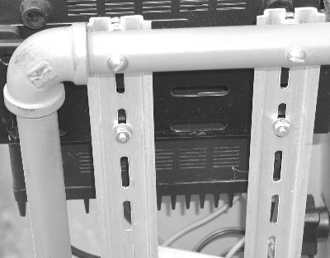
Figure 10 DIN rail to mount IF rig on inside of frame
Lastly, many of us used DIN rail as an adjustable slide for our dish feeds. To prevent the feed from pivoting if bumped, you should have the fixed material underneath equal the width of the inside of the DIN channel. Several guys have used one or two layers of stiff circuit board material because they can solder it to the copper pipe they are using on the offset feed arm. Again, if you have excess DIN rail length, a little is good because that is what will take the blow if something is bumped. But if it’s too long, it will catch on things unnecessarily.

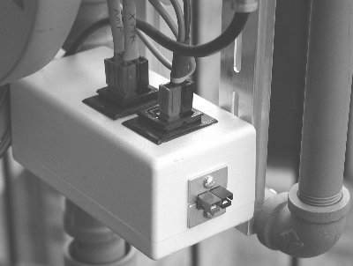
Figure 11 --DC Distribution box on inside of frame
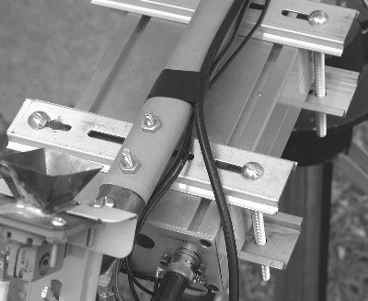
Figure 12 --WØLMS DIN rail clamp
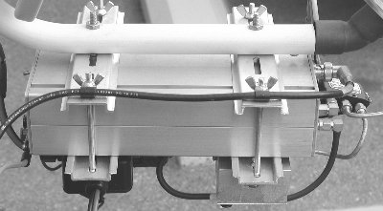
Figure 13 --KØSHF DIN rail clamp
Other details:
Assuming your dish and tripod are not permanently mounted together, your IF rig HAS to be mounted on or near the dish. The point is that you can’t hook up your IF rig at every operating location. For reliability, you need to hook the system elements together once and leave them connected. Tidy up your wiring with cable clamps and wire ties so that floppy wires won’t get snagged.

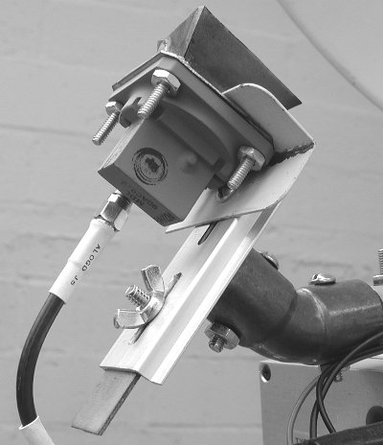
Figure 14 --DIN rail as dish feed mount

The only thing you should have to connect at each operating location is a single DC connection. Distribute the DC on your dish to the transverter, IF rig, amplifier, and keyer. I built up a little distribution box using Anderson PowerPoles. I like how it works but there is one improvement I recommend. You can see the single connection on the end. I should have brought out a 6-inch pigtail of wire with either a line-strain relief or a knot on the inside of the box. This single fixed connection suffers torque from the wire during dish swinging.

Dish Height: In the picture showing two hollow-center tripods, you can see that the tripod has the ability to elevate the center post. This will not be very necessary. What I’m getting at is that if you leave the center post down, you keep the center of gravity low and decrease the moment arm for tipping by the wind. If you place your dish post into the tripod with the center mount in the low position, the dish will likely be about 3.5 to 4 feet above the ground. You will easily operate your IF rig mounted on the inside of the frame from above. I have trouble imagining a situation where you could make a QSO with the dish elevated to 5-5.5 feet that you couldn’t make with the dish at the lower position. One of our operators has removed the elevating gear track from his tripod since he doesn’t use it. The rest of us left ours intact but generally leave the dish in the unelevated position.

Vertical Adjustment—your DSS dish comes with fasteners to set vertical angle. Usually these are just screws or bolts with nuts and lock washers. You need the ability to adjust vertical angle easily. You should replace either the nuts with big knurled knobs or replace the bolt with a knurled knob that has a threaded stud. It depends on your dish. In the Twin Cities we have a chain of odd junk/surplus stores called Axe-Man Surplus where we get these knurled knobs. If your dish has two—one on each side—you can tighten them down for transit and once peaked on the horizon. But just tightening one side is often enough.

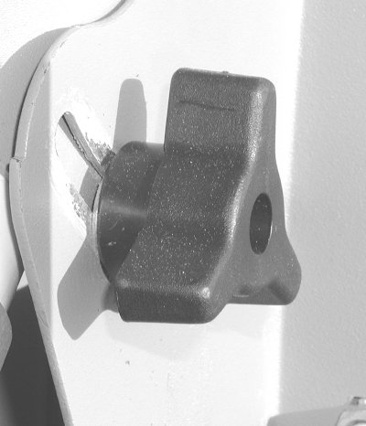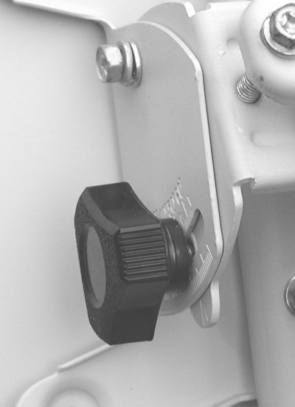
Figure 15 Knurled knobs for easy vertical peaking

Bubble levels—you can see a few of the dishes have levels attached. Initial calibration is the hard part. Once installed, it gives you a good input on training the dish on the horizon despite uneven ground.

DC monitoring—a few guys have incorporated DC voltmeters into their systems to continuously monitor voltage. You can mount the meter on the dish or on the battery. This is helpful because some IF rigs get flaky at certain voltages. The most common problem is flaky SMA relay switching when voltage gets light. You might hear the relays clicking, but it doesn’t mean they are closing well. Three of us have noted this with the charged capacitor/stacked voltage trick used in DEM xverters for external relay keying. This technique stacks 12v on 12v to achieve a 24v pulse to fire a 28v relay. If you are down to 11v, now you’re only firing with 22v.
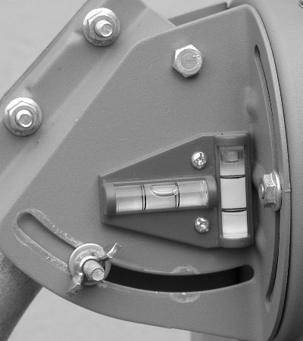
Figure 16 -- WØZQ Bubble Level

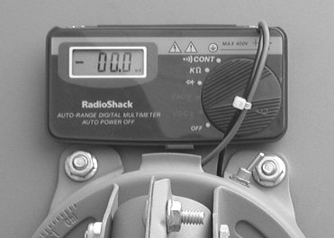
Figure 17 -- WØZQ Voltage Monitor

DC voltage conditioning—one gent ponied up for a DC booster. It takes 9-15 in and gives a steady (adjustable) 13.8 out. It costs about $100. He notes that his relays always fire and he has no LO drift due to changing supply voltage. The item can be found at: http://members.cox.net/w4rry/index.html

Pivot resistance—the wind will try to weathervane your dish. You need some resistance to control that. One method is to use a rubber plumbing reducer with hose clamps. It’s called a “no-hub coupler”. The hose clamp is adjusted to give just the right amount of squeeze yielding turning resistance. The other technique is to use a conduit union bushing with one end fixed and a setscrew in the other end. Once the pipe post is inserted through the conduit collar into the tripod, the setscrew can be tightened to prevent unnecessary pivoting.

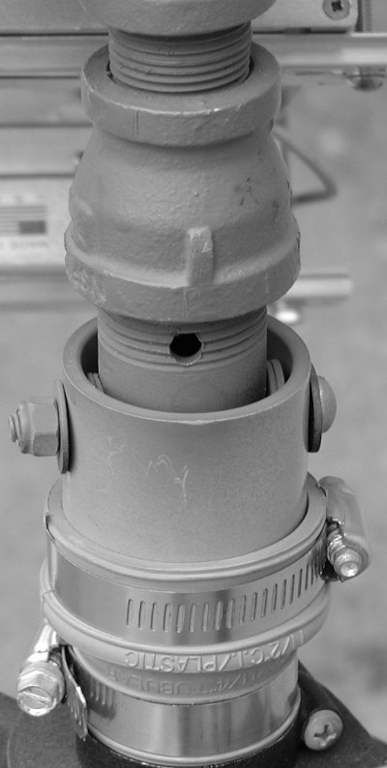
Figure 18 -- Rubber collar with hose clamp for resistance. The bottom hose clamp is the one doing the work. (no-hub collar)
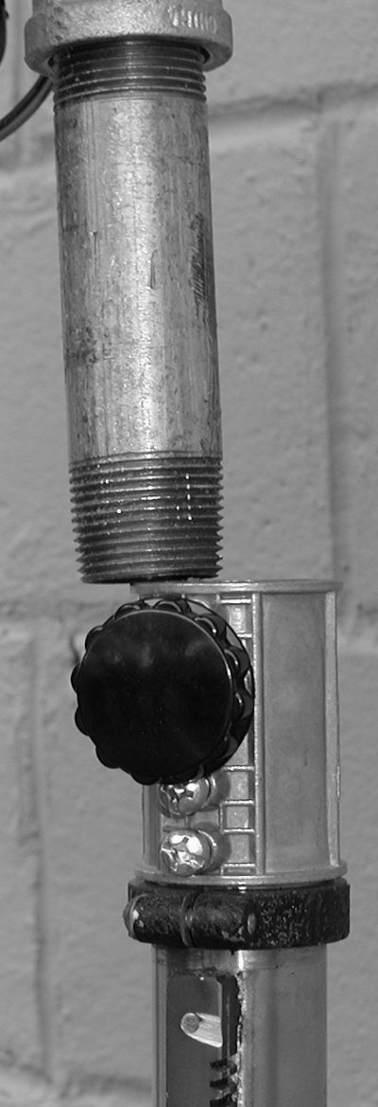
Figure 19 Conduit coupler used as pivot setscrew
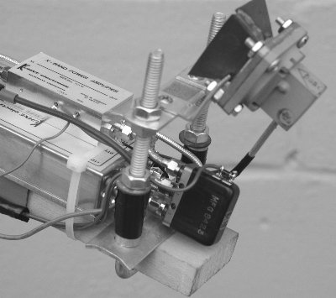
Figure 20 -- WØZQ dishfeed mounting
Two additional dish feed mounting ideas:
WØZQ used a hardwood board as an extension of the boom. Then along the boom he placed a squared off U-bolt (comes that way) where it would place the feed right where it needs to be.

I took 1/8th inch bar stock and had a good friend give it crisp bends right where I needed them. It’s basically two “L’s” nested. I drilled and filed a slot in one piece to give vertical adjustment. Horizontal adjustment is via the center slot in the DIN rail on top. I had to drill and tap two holes for the fixed adjustment screws. What I like about the steel bar is that it is stout. Do you notice a theme here?
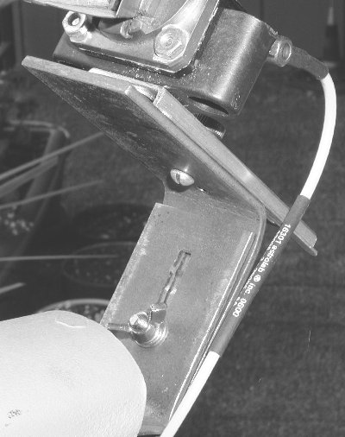
Figure 21 --Stout metal feed mount
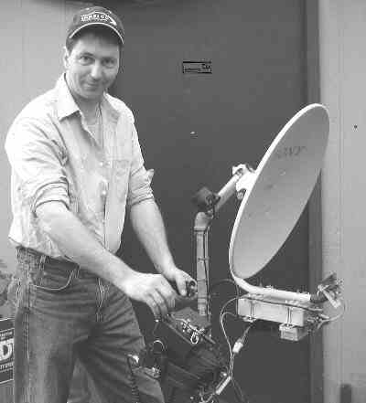
Figure 22 KØSHF shows easy ergonomic layout

NØKP’s novel truck mounted deployment system:

Dave has configured his truck in a really novel way. He has mounted an extension ladder to the bed of the truck. This extension ladder consists of three short sections. The top two sections are free to slide out. Dave has attached a board, which has two mounting fittings for dishes (10GHz and 5.7GHz). When he’s doing run-and-gun operating, he stops the truck, pulls out the ladder-table and works the Q’s. The rigs remain powered from truck power and that way they remain warmed-up and frequency stable. If he gets to a site where he needs to lug the dishes elsewhere, each of the dishes will fit equally well into his tripods.

Credit:
Biggest thanks go to Lenny Klosinski KØSHF for helping us see how to use additional plumbing for mounting equipment, introducing us to DIN rail, helping all of us with dishfeed mounting mechanics, and fashioning many dish feed horns. What you see in this article is the creative evolution imparted by Tony Kessinger, KDØJI; Dave Kleindl, NØKP; Russ Lane WØLMS; and Jon Platt, WØZQ.

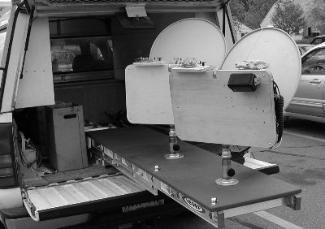
Figure 23 NØKP dishes on a pullout tray
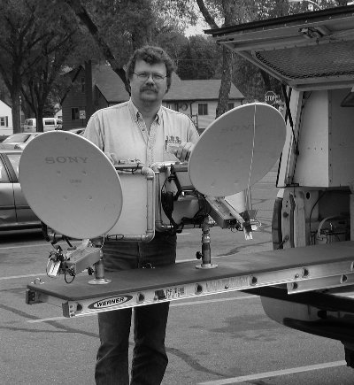
Figure 24 NØKP with 5 and 10 GHz dishes

Notes:
- Paul Wade W1GHZ’s On-Line Antenna book has been a huge resource for all of us for placing our dishfeeds at the appropriate location. http://www.qsl.net/n1bwt/contents.htm

- This article will always be available for viewing with color pictures and much bigger JPEG’s behind each image at: http://w9fz.com/tct/index.html

