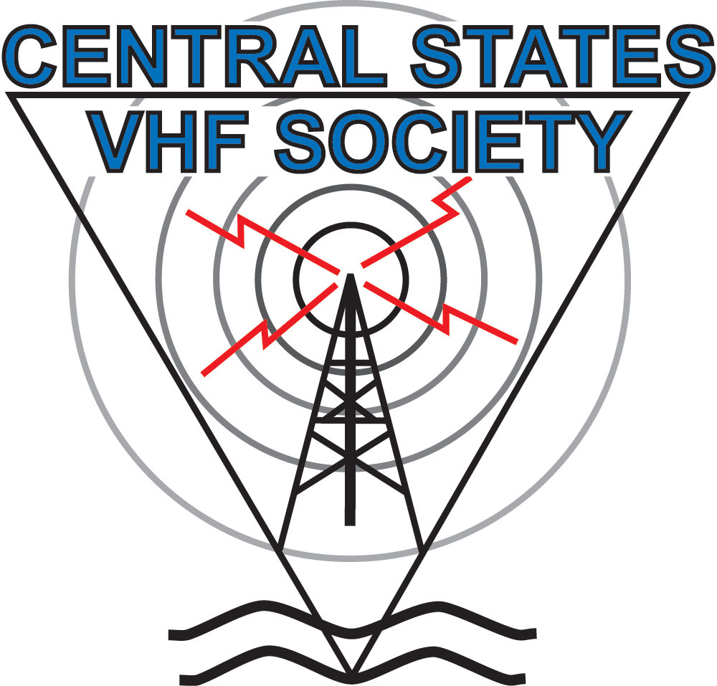
Central States

VHF Society

Ham Radio Activity
and Experimentation
50 MHz and Above

www.csvhfs.org

